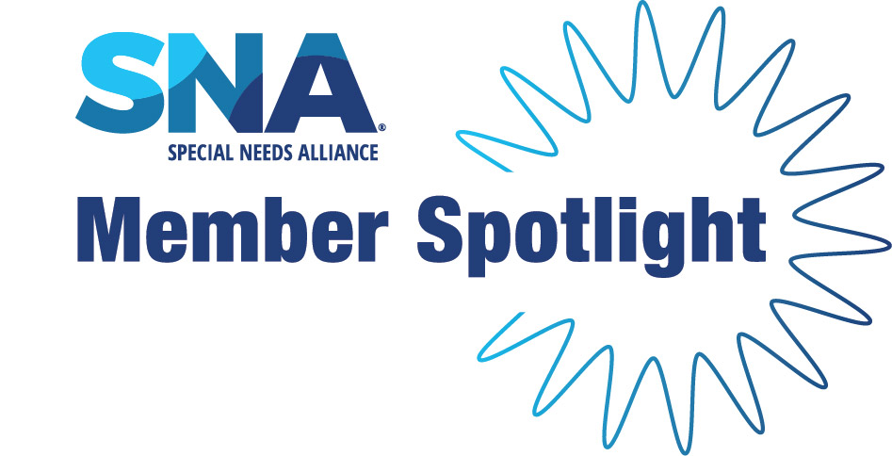

|  |
| --- |
|  |
| Getting to know Fiduciary Counsel Member Anna Méndez What drew you to the practice of special needs planning?  Our law school professors frequently told us to nurture relationships with "people you meet today," since you never know what opportunities may arise "10 years from now." In my 1L year of law school, I met a woman, Nancy Sosa, who had dedicated her career to serving as corporate fiduciary for special needs trust beneficiaries. She was (and still is) incredibly passionate about serving the special needs community. I also have a close relationship with a relative with special needs, so her passion struck me deeply. Nancy and I kept in touch over the years, as I began private practice in 'big law' and dreamed of a way to use my skills and training towards this passion. I was in my 7th year at the firm when an opportunity arose to join Nancy's trust administration team with a strong emphasis on special needs trusts. That was nearly 13 years ago, and just as my professors predicted, almost exactly 10 years after I met Nancy.  How do you describe your work to people who are unfamiliar with it?  Serving as corporate trustee for special needs trusts is more than just managing money and paying bills. Properly executing our duties requires that we wear many hats. To name a few: developing and maintaining relationships with our special needs beneficiaries, gaining trust and understanding to ascertain the beneficiary's needs and goals, keeping our knowledge and understanding of applicable public benefits  up-to-date (including federal, state, and agency rules and regulations), negotiating large transactions such as real estate purchases and home modifications, using investment expertise to plan for both current and future needs, among other things.  We like to refer to ourselves as “professional problem solvers,” because one of our primary roles is to work closely with beneficiaries and their families to find creative solutions that ensure the beneficiary's needs are met while complying with applicable trust and public benefit requirements. If we don't know the answer to a particular issue, we will reach out to our network of resources to find someone who does. Many are surprised to learn about our accessibility to and level of involvement with our beneficiaries and families, including frequent home visits and providing applicable education and resources wherever needed. Behind the corporate facade, we are actual human beings with a passion for helping and serving our clients.    What’s something about you that might surprise others?  I am a musician at heart. I play flute, a little guitar, and I enjoy singing. Starting in law school, I began a 12-year stint as a member of a local Austin mariachi group. I still dream of one day re-joining!  Who or what inspires you the most?  As Michael Jr. says, "When you know your WHY, your WHAT becomes more impactful because you're walking towards or in your purpose." Our special needs trust clients—with many of whom we develop relationships spanning decades—are a deep source of daily inspiration for myself and my team and serve as a continuous reminder of “why” we do what we do. Our clients often have enough challenges on their plate navigating the complex legal, medical, and public benefit systems, not to mention finding their own pathways through daily life. We are grateful for the opportunity to pull from our collective experience and resources to help make things easier and hopefully brighter for them in the days and years ahead.  What is your ideal way to spend a Saturday?  Exploring different places and activities in Austin with our almost-5-year old son. It's so fun to see the city through the eyes of a kid! As a native Austinite, we are also fortunate to have lots of family in town and enjoy the opportunity to spend family time together.  What is a podcast or book that you recommend to others?  The Four Agreements by Don Miguel Ruiz. I provide a printed summary to everyone on my team, because I believe that applying the four principles (Be Impeccable with Your Words, Don't Take Anything Personally, Don't Make Assumptions, Always Do Your Best) to our work helps immensely in serving our clients. As the author has noted, even simply attempting to follow them can shift your perspective, and therefore your experience of life, for the better. |